Exemplar: Create a sales report

Introduction
In the exercise Create a sales report, you were tasked with creating a sales report for Adventure Works, providing the company with insights into its business performance. Specifically, you were asked to:
- Create a line chart to track sales revenue over time, enabling Adventure Works to identify sales peaks, trends, and patterns.
- Visualize the contribution of each product category to total sales using a pie chart.
- Produce a bar chart demonstrating sales by day of the week, reflecting customer buying patterns.
This reading is a guide you can use to compare your work. Your answers may differ from the example answers provided but still be correct.

Power BI Desktop user interface
In this exercise, you created visualizations using Power BI Desktop. Power BI Desktop is updated and released monthly, incorporating customer feedback and new features. You might experience changes in the Power BI Desktop User Interface (UI) that have taken place after the development of this training content. As a result, the screenshots in the videos, readings, or exercises, including the current reading, might not align exactly with how you experience the UI. However, please note that these changes do not impact the functionalities of the UI. Hence, you can still perform all the steps shown in that video, reading, or exercise.

Create a sales report

Step 1: Create a line chart for sales revenue over time
- First, select the Sales Revenue over Time page.
- To create a line chart (a helpful visualization for depicting changes over time, allowing for clear visualization of trends, fluctuations, and patterns), navigate to the Visualizations pane.
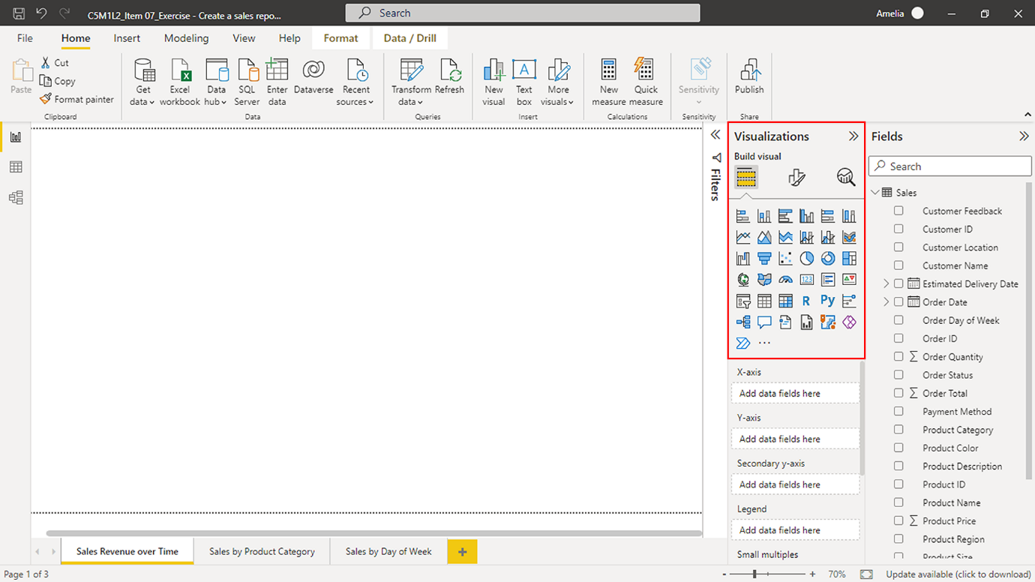
- Select the Line chart icon. An empty chart should appear in the center of your Power BI canvas.
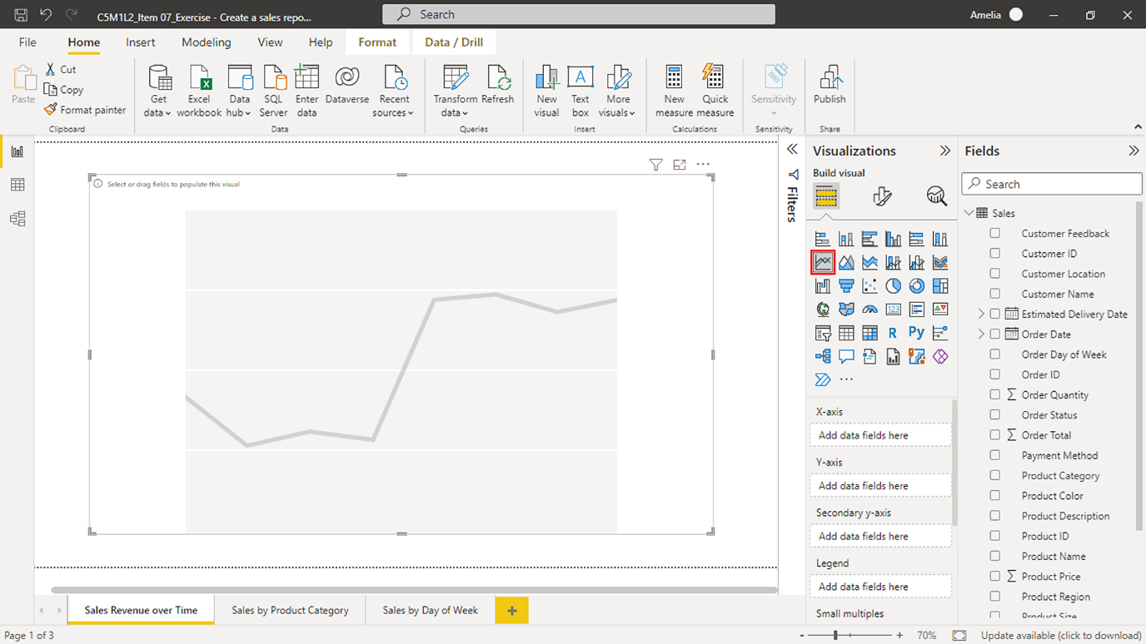
- To start populating this chart with data (by dragging and dropping the relevant fields into the appropriate chart areas), select, hold, and drag the Order Date > Month field across to the X-Axis field well under the Visualizations pane. Note: Order Date will populate the X-Axis area when you release the mouse button. Assigning Order Date > Month to the X-Axis sets the foundation of your time series analysis. In other words, it defines the time frame for sales data analysis.
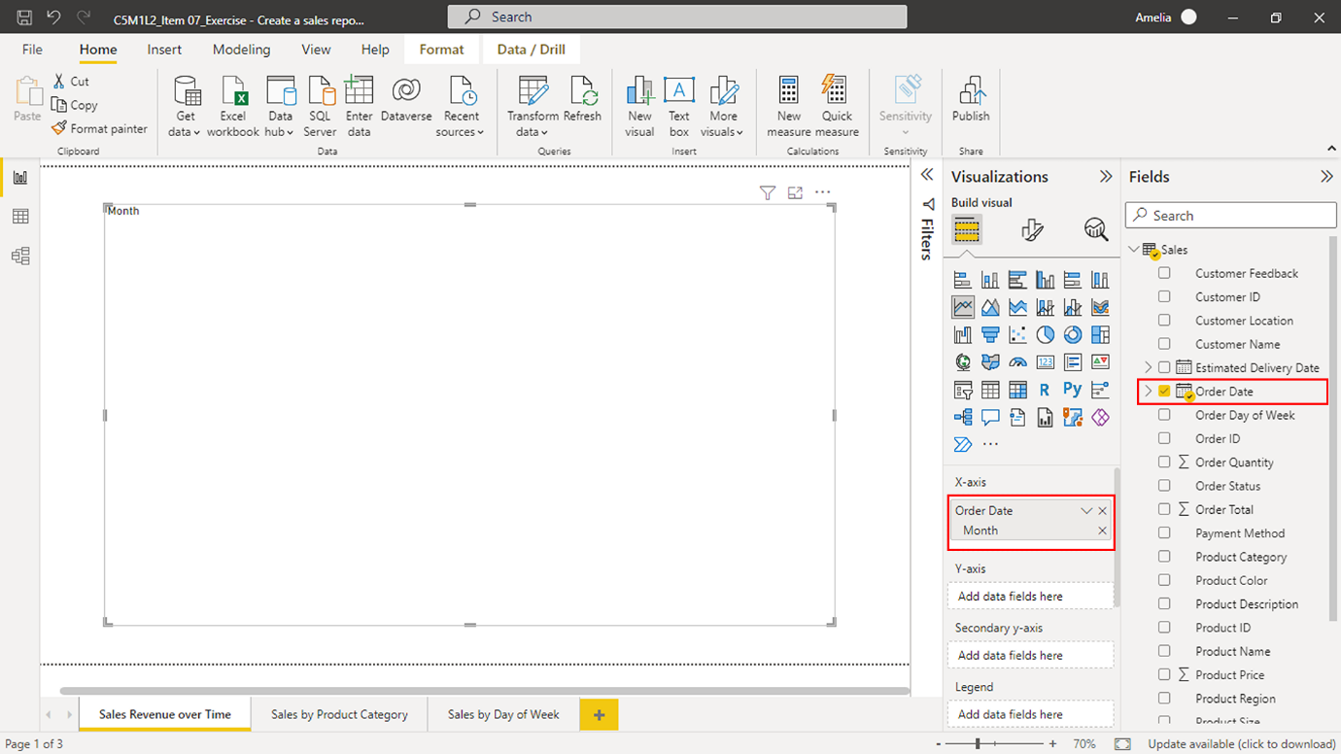
- Next, locate Order Total in the Fields pane. Select it and drag it to the Y-axis field well. This action will define the Y-Axis of your line chart, representing the total sales.
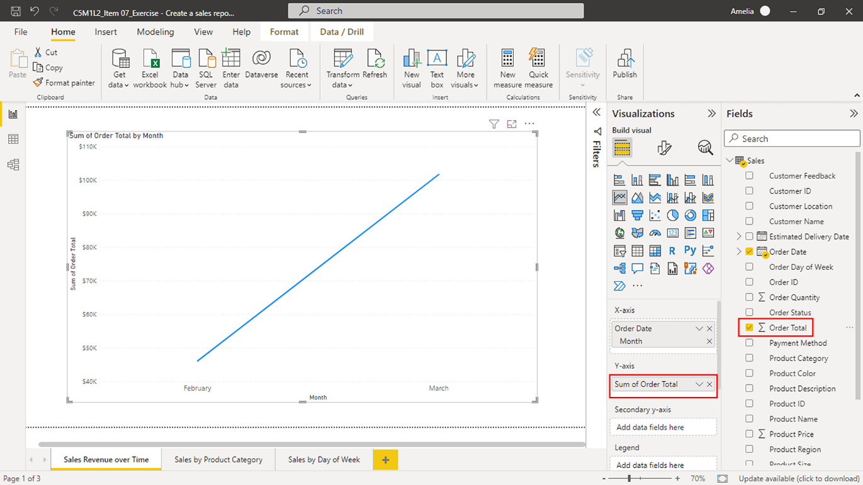
Your line chart now visualizes total sales over time. The Order Date field allows for tracking sales trends across different periods, while the Order Total quantifies the total sales for each date. You can change the chart's size by clicking and dragging its edges.

Step 2: Create a pie chart for sales by product category
Your next instruction was to create a pie chart, a circular statistical graphic divided into slices to illustrate numerical distribution. The aim is to create a pie chart of sales by product category to visualize each product category's contribution to total sales for Adventure Works. Combined with the line chart showing sales revenue over time, it gives a comprehensive view of the sales performance, allowing decision-makers to see the “when” and the “what” of sales revenue.
- Begin by selecting the Sales by Product Category page.
- To create a pie chart, move to the Visualizations pane and select the Pie chart icon. A blank pie chart box will appear in your report canvas.
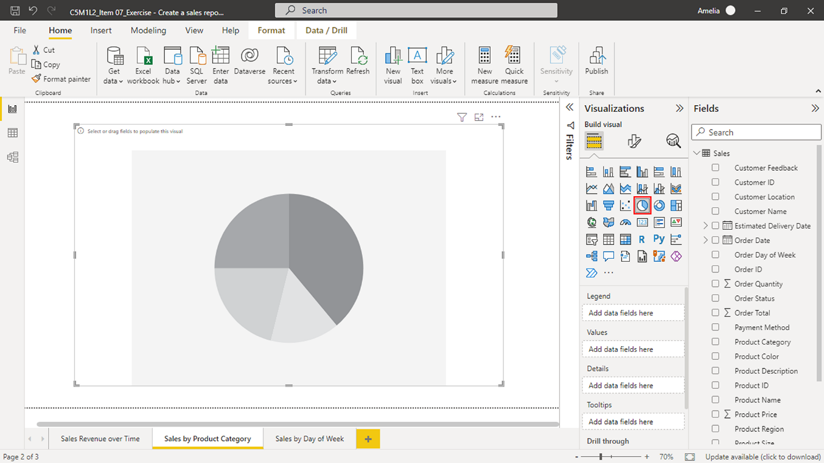
- The next step is to add data to your pie chart. Select the Product Category field in the Adventure Works sales dataset, hold down the mouse button, and then drag the field over to the Legend box under the Visualizations pane. Note: The Legend box represents the categories in your pie chart, with each category assigned a different color in your chart for easy distinction. Adding the Product Category field to the Legend box tells Power BI that you want to show sales data for each product category in your pie chart.
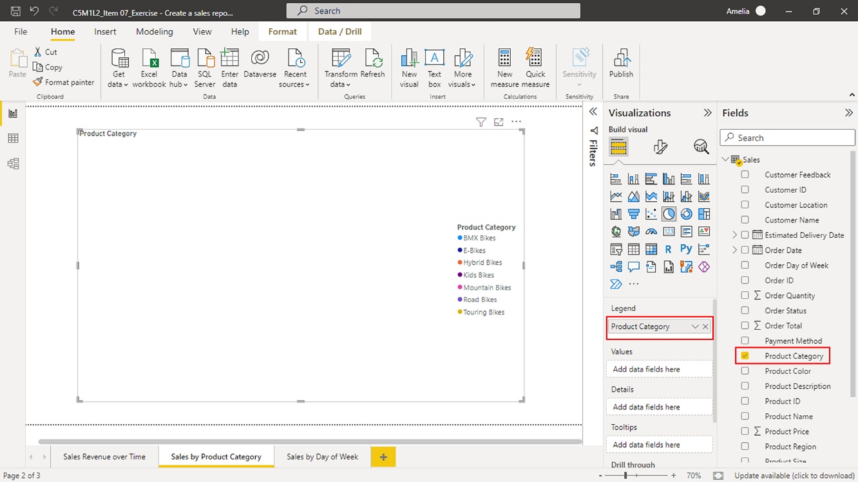
- Next, find the Order Total field, which represents the total sales for each order. Select Order Total and then drag it over to the Values box. Note: The Values box defines what the pie chart measures. In this case, it's the total sales for each product category. By adding Order Total to the Values box, you set the pie chart to display the proportion of total sales represented by each product category.
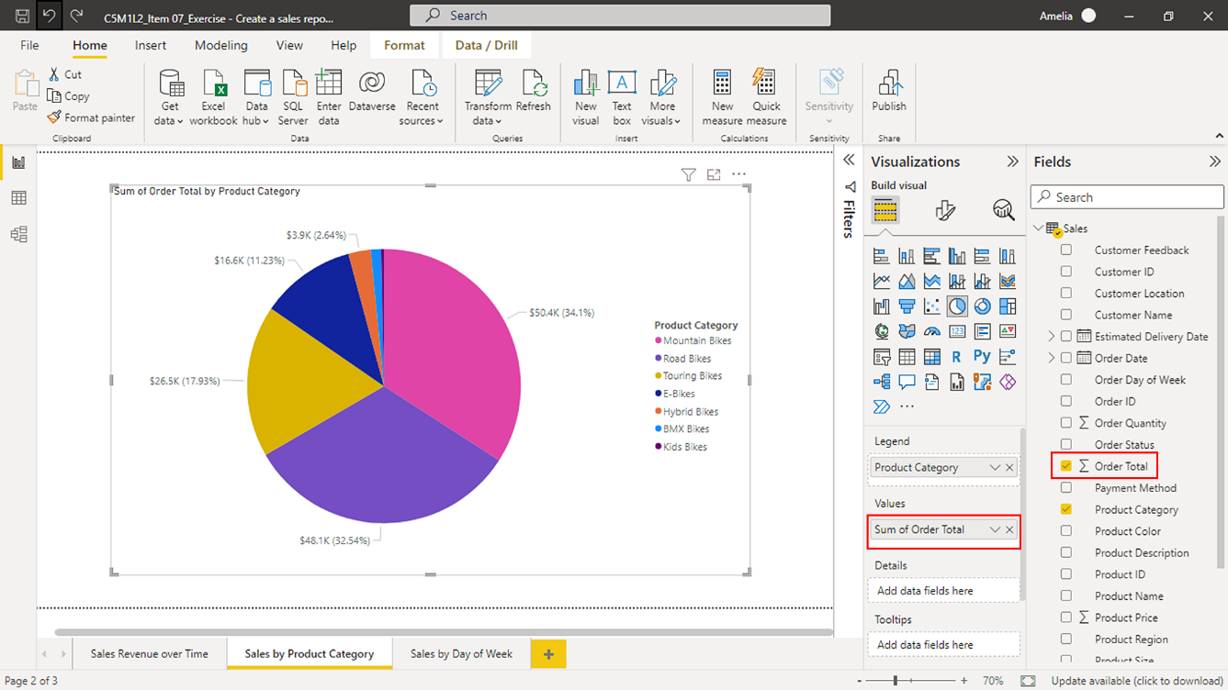
By completing these steps, your pie chart will come to life on your report canvas. Each slice of the pie represents a different product category, and their sizes correspond to the total sales for that category. Viewers can hover over each slice to display a tooltip with the exact sales figure.

Step 3: Create a stacked bar chart for sales by day of the week
Now you need to create a stacked bar chart that visualizes sales by the day of the week. Understanding product sales by day of the week can help Adventure Works identify customer buying patterns and adjust inventory, marketing, and sales strategies accordingly. For example, if sales of bikes are high on a Monday, the company might want to increase its stock based on the increased demand.
- Select the Sales by Day of Week page.
- To create a blank bar chart for this analysis, navigate to the Visualizations pane and select the Stacked bar chart icon. An empty bar chart box should now be on your report canvas. Tip: The Stacked bar chart is best suited for comparing different categories of a variable (in this case, days of the week) against a numerical value (total sales).
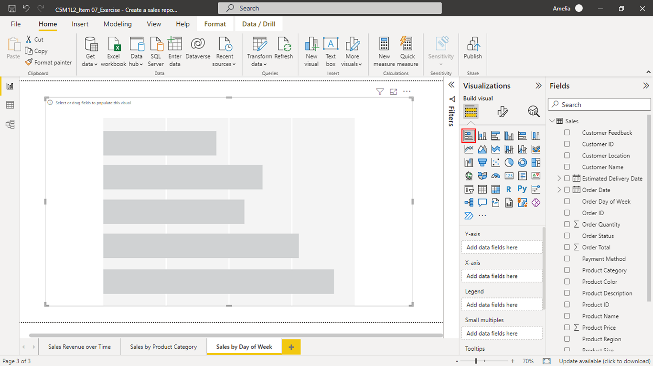
- Select the Order Day of Week field and drag it to the Y-axis box to add data to your bar chart. Note: This field can reveal sales trends by capturing the day of the week each order was placed. For example, Adventure Works may find that most orders are placed on a specific day.
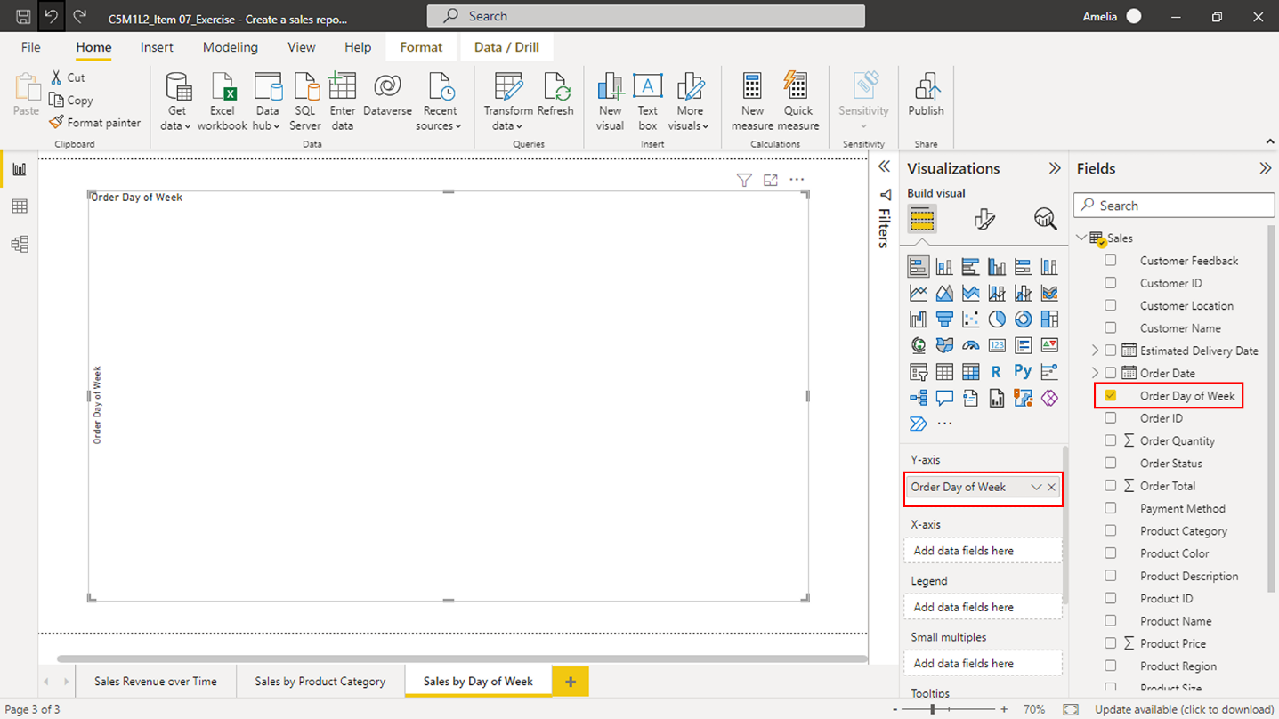
- Next, select and drag the Order Total field to the X-axis box. This action tells Power BI to populate the bars of your chart with the total sales values.
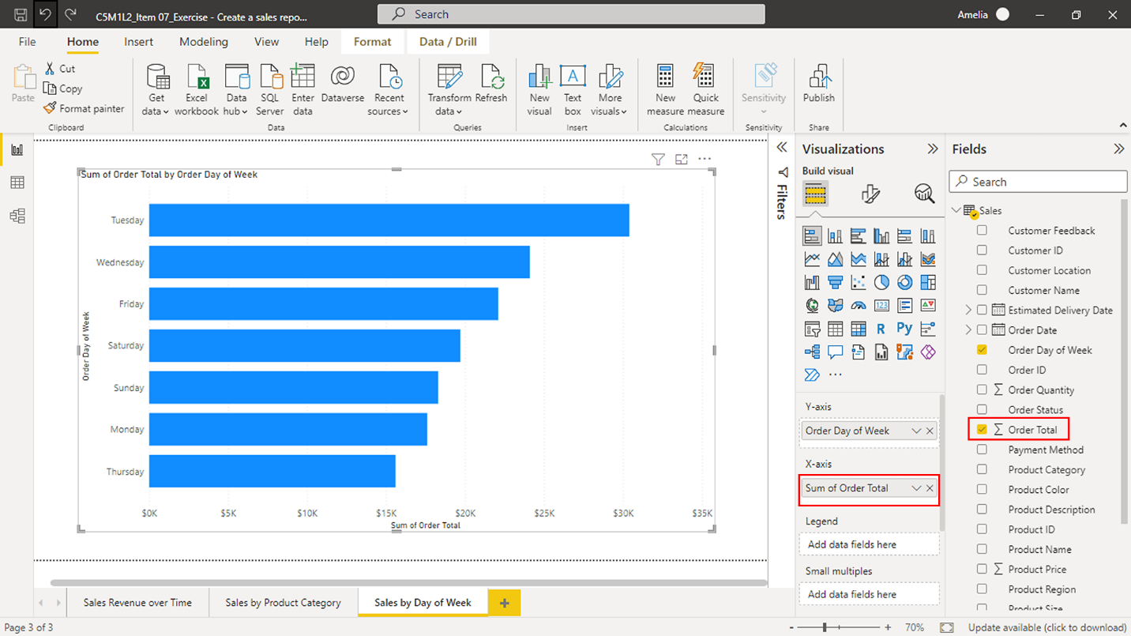
These steps should fully populate your stacked bar chart. Each bar represents a different day of the week, and the height of each bar signifies the total sales made on that day.

Step 4: Add a slicer visual to alter the data to reflect changes
Slicers can provide Adventure Works with a way to filter data interactively, enabling stakeholders to select one or more items and filter the rest of the visuals in the report accordingly. For instance, adding a slicer for Order Date would allow viewers to filter all visuals to display data from a specific time range. This could be invaluable for time-bound sales analysis—such as month-end sales, quarterly performance, or year-over-year trends—which are crucial for strategic planning and decision-making.
- In the Visualizations pane, select the Slicer icon to add an empty slicer box to your report canvas.
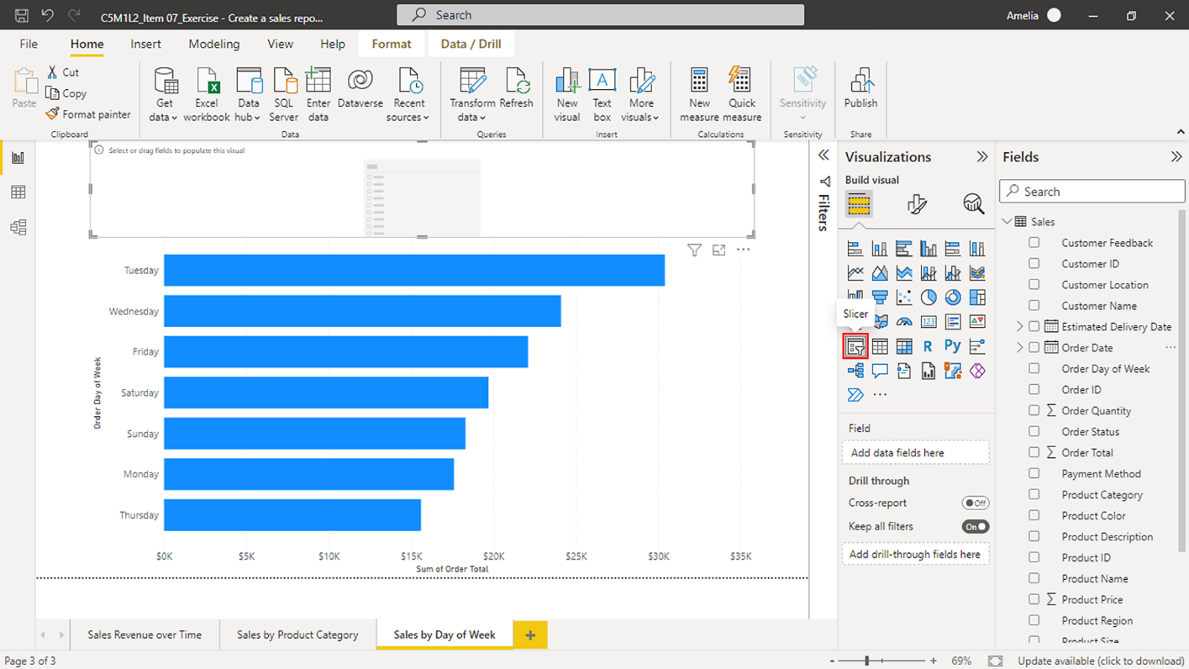
- To add data to your slicer, select and hold the Order Date field from your dataset in the Fields pane. Then, drag it to the Field area under the Visualizations pane. Release the mouse button to populate the slicer with data from the Order Date field.
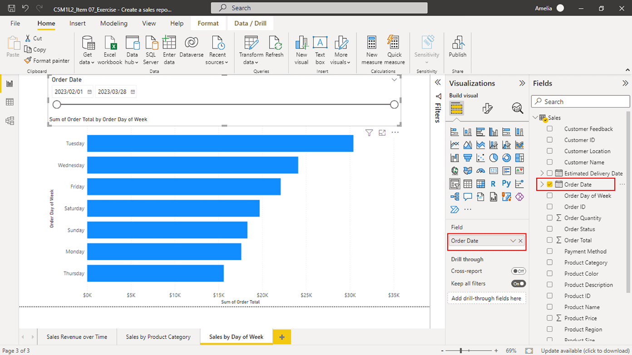
- A range of dates will appear after adding the Order Date to the slicer. Note: By default, Power BI automatically recognizes the Order Date field as containing date data and thus provides a slider for ease of use. This slider will allow stakeholders to adjust the range of dates they want to examine data for in the report.
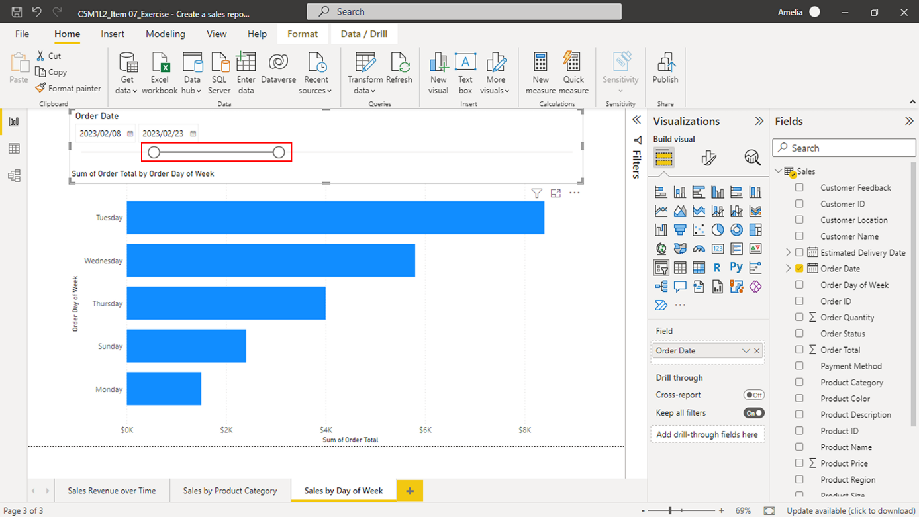
You have now added an interactive slicer to your sales report. Anytime a user adjusts the range on the Order Date slicer, all visuals in the report will update to reflect the selected date range. Slicers empower you to create informative, engaging, and flexible reports for users, catering to various data analysis needs and preferences.

Conclusion
By creating your own visualizations in the Create a sales report exercise, you gained first-hand experience using Power BI to convert raw data into easily understandable insights. You transformed sales data into an interactive story that conveys Adventure Works' sales revenue over time! Companies like Adventure Works can use reports like the one you created to make data-driven decisions, essential for driving business growth in today's data-rich world.

